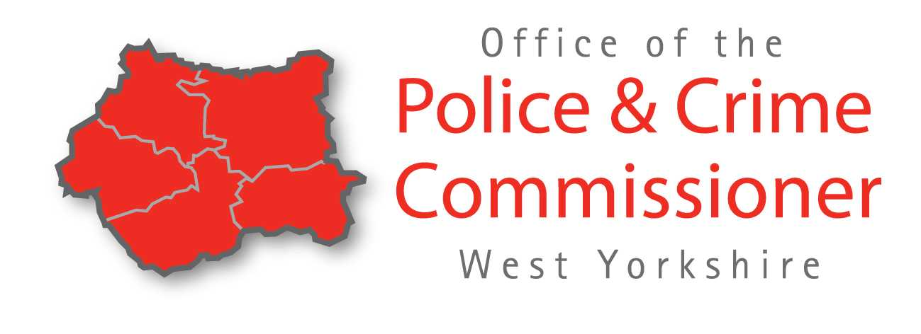
West Yorkshire Police Council Tax Information 2020/2021

Keeping our communitues safe and feeling safe

As your Police and Crime Commissioner (PCC) I want to continue to put resources into West Yorkshire to increase frontline visible policing to make sure our communities are safe and feel safe.

79% of respondents to my survey on the precept supported the 4.99% increase proposed which equates to no more than an extra £7.26 a year for most households in West Yorkshire.

This will allow PCSO numbers to be maintained, and an overall additional 311 Police Officer recruits as well as Police Staff recruitment in excess of 100. This means key areas of investment can be supported, such as specialist investigators using new digital and forensic techniques to improve criminal justice outcomes for victims and witnesses.

Mark Burns-Williamson OBE
West Yorkshire’s Police and Crime Commissioner

Where the money came from 2020/2021

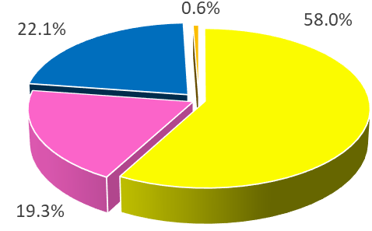
Yellow – Government Grant 58.0%
Pink – Income 19.3%
Blue – Precept (police Council Tax) 22.1%
Orange – Other 0.6%

What the money is spent on 2020/2021
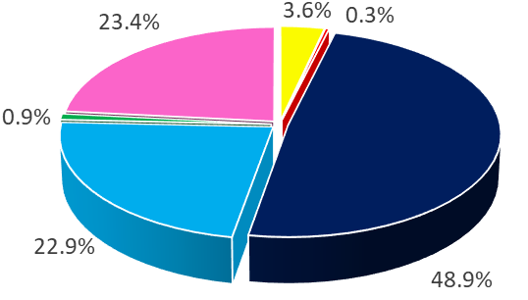
Yellow – PCSOs 3.6%
Dark Blue – Police Officers 48.9%
Red – Office of the Police and Crime Commissioner 0.3%
Light Blue – Police Staff 22.9%
Green – Borrowing 0.9%
Pink – Running Costs – e.g premises, vehicle 23.4%

Budget | 2019 – 2020  £m | 2020 – 2021  £m
Gross Expenditure | 547.333 | 589.605
Council Tax Requirement | 122.018 | 130.024

Summary: There will be 4.99% increase to the annual police council tax.

Council  Tax Band | Current cost  per year £ | 2020/21  cost £ | Annual  increase £ | Per week  increase £
A | 124.63 | 130.85 | 6.22 | 0.12
B | 145.40 | 152.66 | 7.26 | 0.14
C | 166.18 | 174.47 | 8.29 | 0.16
D | 186.95 | 196.28 | 9.33 | 0.18
E | 228.49 | 239.90 | 11.40 | 0.22
F | 270.04 | 283.51 | 13.47 | 0.26
G | 311.58 | 327.13 | 15.55 | 0.30
H | 373.90 | 392.56 | 18.66 | 0.36
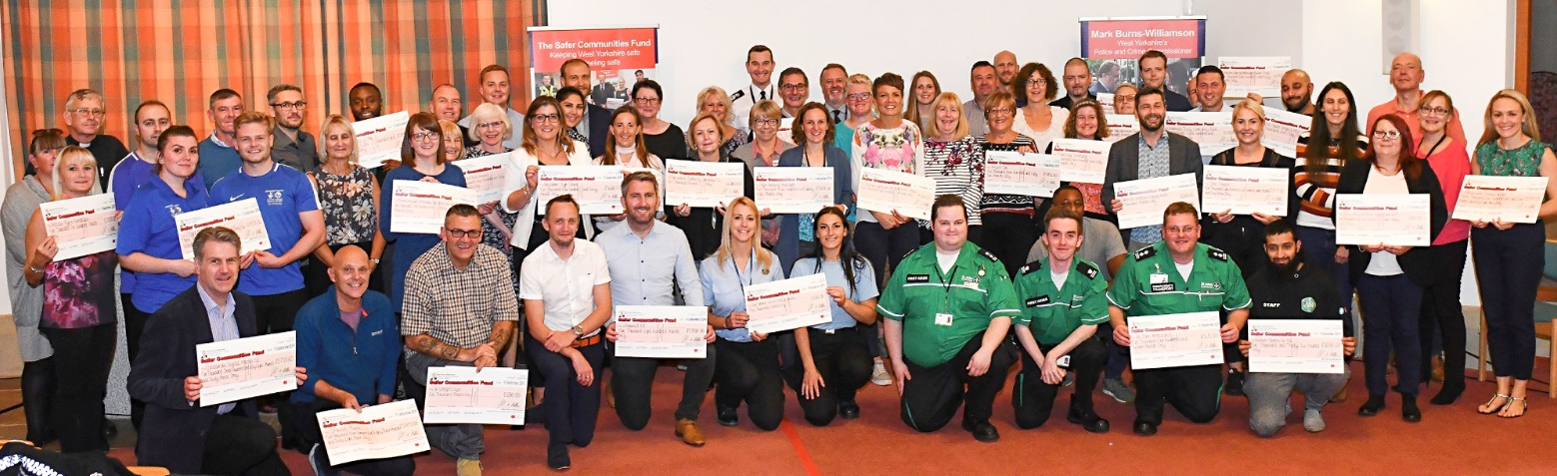

I am delivering for communities across West Yorkshire by:
- Recruiting more police officers, protecting PCSO numbers and strengthening frontline and neighbourhood policing.
- Improving services for victims and witnesses, including launching the first ever Victims Strategy for West Yorkshire and working with partners to create a new purpose built Sexual Assault Referral Centre (SARC) facility.
- Awarding over £2.96m of recovered Proceeds of Crime money to community groups and organisations working to keep communities safe through my Safer Communities Fund.
- Working to tackle violent crime including successfully securing funding to create a West Yorkshire Violence Reduction Unit.
- Working with key partners to co-ordinate resources to tackle the priorities in the West Yorkshire Police and Crime Plan such as road safety, cyber-crime, child sex exploitation and domestic abuse.
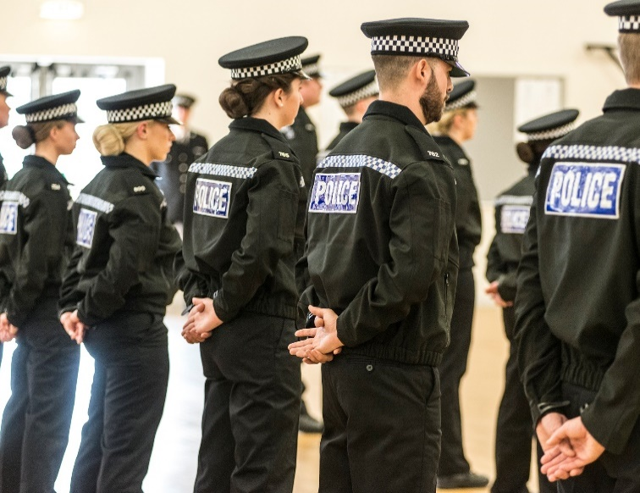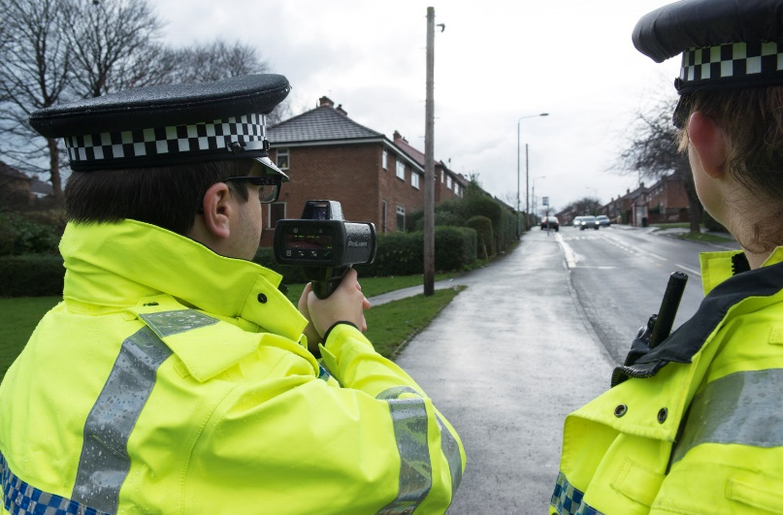

Contact

To find out more or contact Mark:

Telephone: 01924 294000
Email: contact@westyorkshire.pcc.pnn.gov.uk
Website: www.westyorkshire-pcc.gov.uk
Twitter: @WestYorksOPCC
Facebook: @WestYorksOPCC

